**Document Library Permissions**

When site-level permissions are not suitable for your situation, then the next level where we can set permissions is on the document library or lists in SharePoint. To change the permissions on a document library we first need to open the library:

1. Click on Settings (gear icon)
2. Choose Library Settings

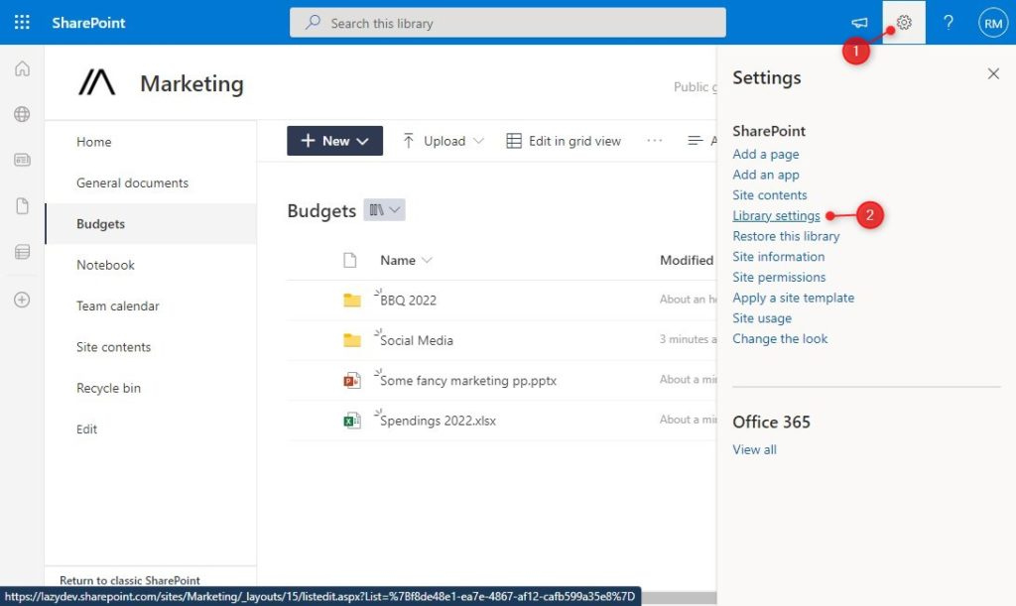

1. Click on Permissions for this document library

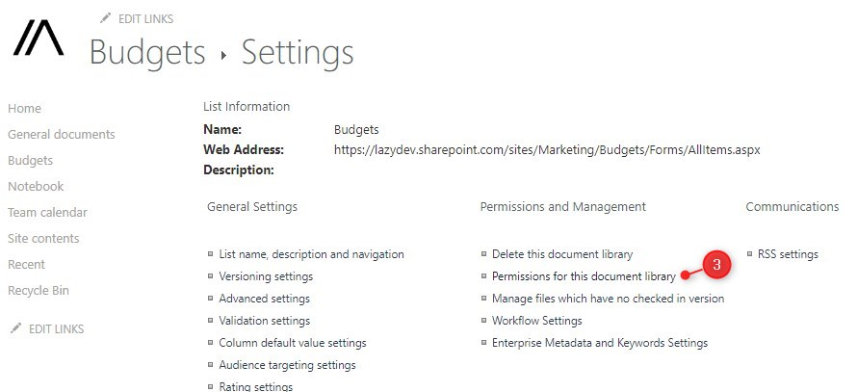Document Library Permissions

We will now see the same permissions as we have set at site level. So the first step is to stop inheriting the permissions from the parent. This will copy all existing permissions to the document library, making them unique.

Note

Keep in mind that changes made at site level later are not applied to this document library after you stop inheriting. So users who are now member at site level, will remain member of the document library if you remove them later at site level

1. Click on **Stop Inheriting Permissions** and click **Ok** on the warning

We can now modify the permissions just as we did at site level. This means that we can add a custom security group, grant additional permissions to users or groups, or change the permission level of the existing groups.

For example, we can remove the members, visitors, and testers from the document library, so that only the owners of the SharePoint site can access the Budgets document library.

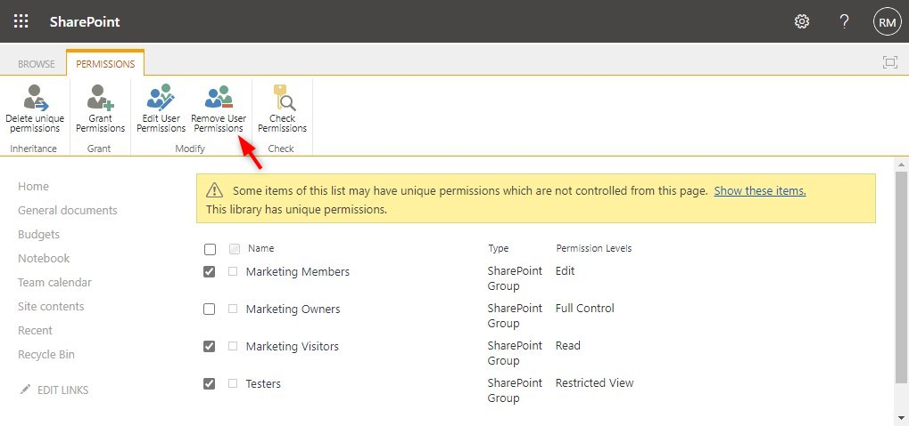Remove user permissions

**Folder Permissions**

We can also create custom permissions at the folder level in SharePoint. Keep in mind that custom folder permissions are harder to keep track of, so make sure that you document them properly and don’t use them too much.

To set unique permissions on a folder in SharePoint first select or hover over the folder:

1. Click on the **3 dots (show action)**
2. Choose **Manage Access**

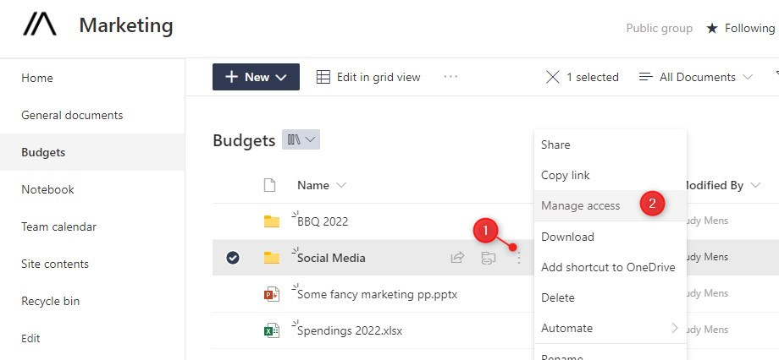SharePoint Folder Permissions

Here we have a couple of options, we can create a link that gives access to the **folder (3)**, just like the normal sharing options. Or directly add a user to the**folder (4).** But it’s also possible to create unique permissions, just like with the document library. Click on **Advanced (5)** to view the permissions settings.

The advanced permissions work the same as the document library. First, stop inheriting the permissions and then create your own custom permissions for the folder.

**File Permissions**

In SharePoint, it’s even possible to add unique permissions to a file. Now just like folders, don’t use this too much. You will easily lose track of all the unique permissions. Setting file permissions works exactly the same as folder permissions in SharePoint.

1. Click on the **3 dots** (Show actions) behind the file
2. Select **Manage Access**
3. Click on **Advanced**to create unique permissions

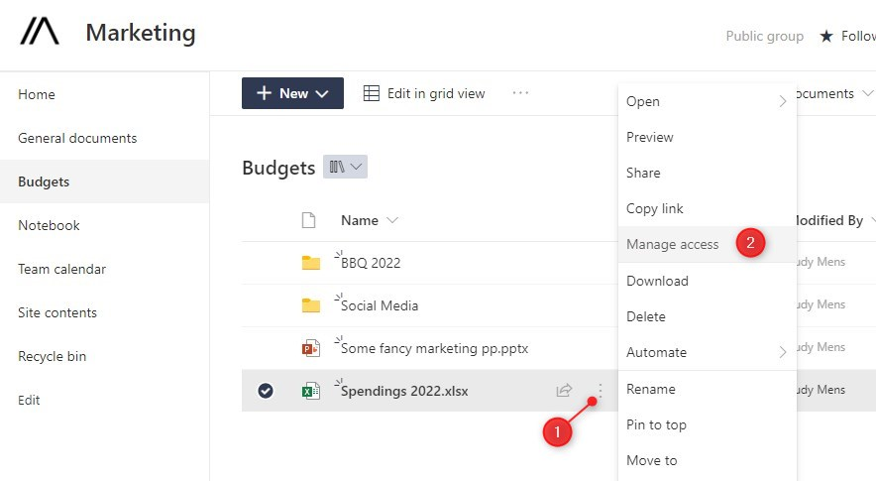

Refer to the steps above on how to stop inheriting the parent permissions and add unique security groups, users, and/or permission levels.